140

Условия при которых f = 1: 1≤|x3x2x1-x5x4|≤3

Условия при которых f = d: | x3x2x1-x5x4|=0

|  |  |  |  |  |  |  |  |
| --- | --- | --- | --- | --- | --- | --- | --- |
| N | X1X2X3X4X5 | X3X2X1 | (X3X2X1)10 | X5X4 | (X5X4)10 | |-| | f |
| 0 | 00000 | 000 | 0 | 00 | 0 | 0 | d |
| 1 | 00001 | 000 | 0 | 10 | 2 | 2 | 1 |
| 2 | 00010 | 000 | 0 | 01 | 1 | 1 | 1 |
| 3 | 00011 | 000 | 0 | 11 | 3 | 3 | 1 |
| 4 | 00100 | 100 | 4 | 00 | 0 | 4 | 0 |
| 5 | 00101 | 100 | 4 | 10 | 2 | 2 | 1 |
| 6 | 00110 | 100 | 4 | 01 | 1 | 3 | 1 |
| 7 | 00111 | 100 | 4 | 11 | 3 | 1 | 1 |
| 8 | 01000 | 010 | 2 | 00 | 0 | 2 | 1 |
| 9 | 01001 | 010 | 2 | 10 | 2 | 0 | d |
| 10 | 01010 | 010 | 2 | 01 | 1 | 1 | 1 |
| 11 | 01011 | 010 | 2 | 11 | 3 | 1 | 1 |
| 12 | 01100 | 110 | 6 | 00 | 0 | 6 | 0 |
| 13 | 01101 | 110 | 6 | 10 | 2 | 4 | 0 |
| 14 | 01110 | 110 | 6 | 01 | 1 | 5 | 0 |
| 15 | 01111 | 110 | 6 | 11 | 3 | 3 | 1 |
| 16 | 10000 | 001 | 1 | 00 | 0 | 1 | 1 |
| 17 | 10001 | 001 | 1 | 10 | 2 | 1 | 1 |
| 18 | 10010 | 001 | 1 | 01 | 1 | 0 | d |
| 19 | 10011 | 001 | 1 | 11 | 3 | 2 | 1 |
| 20 | 10100 | 101 | 5 | 00 | 0 | 5 | 0 |
| 21 | 10101 | 101 | 5 | 10 | 2 | 3 | 1 |
| 22 | 10110 | 101 | 5 | 01 | 1 | 4 | 0 |
| 23 | 10111 | 101 | 5 | 11 | 3 | 2 | 1 |
| 24 | 11000 | 011 | 3 | 00 | 0 | 3 | 1 |
| 25 | 11001 | 011 | 3 | 10 | 2 | 1 | 1 |
| 26 | 11010 | 011 | 3 | 01 | 1 | 2 | 1 |
| 27 | 11011 | 011 | 3 | 11 | 3 | 0 | d |
| 28 | 11100 | 111 | 7 | 00 | 0 | 7 | 0 |
| 29 | 11101 | 111 | 7 | 10 | 2 | 5 | 0 |
| 30 | 11110 | 111 | 7 | 01 | 1 | 6 | 0 |
| 31 | 11111 | 111 | 7 | 11 | 3 | 4 | 0 |

Канонический вид КДНФ : (¬x1∧¬x2∧¬x3∧¬x4∧x5) ∨ (¬x1∧¬x2∧¬x3∧x4∧¬x5) ∨ (¬x1∧¬x2∧¬x3∧x4∧x5) ∨ (¬x1∧¬x2∧x3∧¬x4∧x5) ∨ (¬x1∧¬x2∧x3∧x4∧¬x5) ∨ (¬x1∧¬x2∧x3∧x4∧x5) ∨ (¬x1∧x2∧¬x3∧¬x4∧¬x5) ∨ (¬x1∧x2∧¬x3∧x4∧¬x5) ∨ (¬x1∧x2∧¬x3∧x4∧x5) ∨ (¬x1∧x2∧x3∧x4∧x5) ∨ (x1∧¬x2∧¬x3∧¬x4∧¬x5) ∨ (x1∧¬x2∧¬x3∧¬x4∧x5) ∨ (x1∧¬x2∧¬x3∧x4∧x5) ∨ (x1∧¬x2∧x3∧¬x4∧x5) ∨ (x1∧¬x2∧x3∧x4∧x5) ∨ (x1∧x2∧¬x3∧¬x4∧¬x5) ∨ (x1∧x2∧¬x3∧¬x4∧x5) ∨ (x1∧x2∧¬x3∧x4∧¬x5)

ККНФ-----: (x1∨x2∨x3∨x4∨x5) ∧ (x1∨x2∨x3∨¬x4∨x5) ∧ (x1∨x2∨x3∨¬x4∨¬x5) ∧ (x1∨x2∨¬x3∨x4∨x5) ∧ (x1∨x2∨¬x3∨x4∨¬x5) ∧ (x1∨x2∨¬x3∨¬x4∨¬x5) ∧ (x1∨¬x2∨x3∨x4∨¬x5) ∧ (x1∨¬x2∨¬x3∨x4∨x5) ∧ (¬x1∨x2∨x3∨x4∨x5) ∧ (¬x1∨x2∨x3∨x4∨¬x5) ∧ (¬x1∨x2∨x3∨¬x4∨x5) ∧ (¬x1∨x2∨¬x3∨x4∨¬x5) ∧ (¬x1∨x2∨¬x3∨¬x4∨x5) ∧ (¬x1∨x2∨¬x3∨¬x4∨¬x5) ∧ (¬x1∨¬x2∨x3∨¬x4∨¬x5) ∧ (¬x1∨¬x2∨¬x3∨¬x4∨x5)

|  |  |  |  |  |  |  |  |  |  |  |  |
| --- | --- | --- | --- | --- | --- | --- | --- | --- | --- | --- | --- |
| **№** | **K0** |  | **№** | **K1** |  |  | **№** | **K2** |  | **№** | **Z(f)** |
| 1 | 00000 | ✓ | 1 | 0000X | 1-2 | ✓ | 1 | 000XX | 1-9 2-5 | 1 | 00001 |
| 2 | 00001 | ✓ | 2 | 000X0 | 1-3 | ✓ | 2 | 0X00X | 1-21 4-7 | 2 | 10011 |
| 3 | 00010 | ✓ | 3 | X0000 | 1-13 | ✓ | 3 | X000X | 1-28 3-8 | 3 | 0x110 |
| 4 | 00011 | ✓ | 4 | 0X000 | 1-8 | ✓ | 4 | X00X0 | 2-29 3-12 | 4 | 1x100 |
| 5 | 00101 | ✓ | 5 | 00X01 | 2-5 | ✓ | 5 | 0X0X0 | 4-11 | 5 | x10x0 |
| 6 | 00110 | ✓ | 6 | 000X1 | 2-4 | ✓ | 6 | XX000 | 4-30 | 6 | 01x1x |
| 7 | 00111 | ✓ | 7 | 0X001 | 2-9 | ✓ | 7 | 00XX1 | 5-13 6-16 | 7 | x11x1 |
| 8 | 01000 | ✓ | 8 | X0001 | 2-14 | ✓ | 8 |  |  | 8 | 11x0x |
| 9 | 01001 | ✓ | 9 | 0001X | 3-4 | ✓ | 9 | 0X0X1 | 6-22 |  |  |
| 10 | 01010 | ✓ | 10 | 00X10 | 3-6 |  | 10 | X00X1 | 6-31 |  |  |
| 11 | 01011 | ✓ | 11 | 0X010 | 3-10 | ✓ | 11 |  |  |  |  |
| 12 | 01111 | ✓ | 12 | X0010 | 3-15 | ✓ |  |  |  |  |  |
| 13 | 10000 | ✓ | 13 | 00X11 | 4-7 | ✓ |  |  |  |  |  |
| 14 | 10001 | ✓ | 14 | 0X011 | 4-11 |  |  |  |  |  |  |
| 15 | 10010 | ✓ | 15 | X0011 | 4-16 |  |  |  |  |  |  |
| 16 | 10011 | ✓ | 16 | 001X1 | 5-7 | ✓ |  |  |  |  |  |
| 17 | 10101 | ✓ | 17 | X0101 | 5-17 |  |  |  |  |  |  |
| 18 | 10111 | ✓ | 18 | 0011X | 6-7 |  |  |  |  |  |  |
| 19 | 11000 | ✓ | 19 | 0X111 | 7-12 |  |  |  |  |  |  |
| 20 | 11001 | ✓ | 20 | X0111 | 7-18 |  |  |  |  |  |  |
| 21 | 11010 | ✓ | 21 | 0100X | 8-9 | ✓ |  |  |  |  |  |
| 22 | 11011 | ✓ | 22 | 010X1 | 9-11 | ✓ |  |  |  |  |  |
|  |  |  | 23 | X1001 | 9-20 |  |  |  |  |  |  |
|  |  |  | 24 | 0101X | 10-11 |  |  |  |  |  |  |
|  |  |  | 25 | X1010 | 10-21 |  |  |  |  |  |  |
|  |  |  | 26 | 01X11 | 11-12 |  |  |  |  |  |  |
|  |  |  | 27 | X1011 | 11-22 |  |  |  |  |  |  |
|  |  |  | 28 | 1000X | 13-14 | ✓ |  |  |  |  |  |
|  |  |  | 29 | 100X0 | 13-15 | ✓ |  |  |  |  |  |
|  |  |  | 30 | 1X000 | 13-19 | ✓ |  |  |  |  |  |
|  |  |  | 31 | 100X1 | 14-16 | ✓ |  |  |  |  |  |
|  |  |  | 32 | 1X001 | 14-20 |  |  |  |  |  |  |
|  |  |  | 33 | 1001X | 15-16 |  |  |  |  |  |  |
|  |  |  | 34 | 1X010 | 15-21 |  |  |  |  |  |  |
|  |  |  | 35 | 10X11 | 16-18 |  |  |  |  |  |  |
|  |  |  | 36 | 1X011 | 16-22 |  |  |  |  |  |  |
|  |  |  | 37 | 101X1 | 17-18 |  |  |  |  |  |  |
|  |  |  | 38 | 1100X | 19-20 |  |  |  |  |  |  |
|  |  |  | 39 | 110X0 | 19-21 |  |  |  |  |  |  |
|  |  |  | 40 | 110X1 | 20-22 |  |  |  |  |  |  |
|  |  |  | 41 | 1101X | 21-22 |  |  |  |  |  |  |

*Составление импликантной таблицы.*



*Определение существенных импликант*

Все импликанты – существенные, так как каждая покрывают вершины от 1..12, не покрытые другими импликантами.

Ядро покрытия:

$T=\left\{\begin{aligned}00001 \\ 0X110 \\ 1X100 \\ 01X1X \\ 11X0X \\ 10011\end{aligned}\right\}$ $C_{min}(f)=\left\{\begin{aligned}00001 \\ 0X110 \\ 1X100 \\ 01X1X \\ 11X0X \\ 10011\end{aligned}\right\}$ Sa = 24, Sb= 30

f = (x1x2¬x4) ∨ (¬x1x2x4) ∨ (x1x3¬x4¬x5) ∨ (¬x1x3x4¬x5) ∨ (x1¬x2¬x3x4x5) ∨ (¬x1¬x2¬x3¬x4x5)

**2.4. Минимизация булевой функции на картах Карно**

**2.4.1. Определение МДНФ**

|  |  |  |  |  |  |  |  |  |
| --- | --- | --- | --- | --- | --- | --- | --- | --- |
| x1x2/x3x4x5 | 000 | 001 | 011 | 010 | 110 | 111 | 101 | 100 |
| 00 | 0 | 1 | 0 | 0 | 1 | 0 | 0 | 0 |
| 01 | D | 0 | 1 | 1 | 1 | 1 | D | 0 |
| 11 | 1 | 1 | 0 | D | 0 | D | 1 | 1 |
| 10 | 0 | 0 | 1 | 0 | 0 | 0 | 0 | 1 |

**Минимизированная ДНФ:**

f = (x1x2¬x4) ∨ (¬x1x2x4) ∨ (x1x3¬x4¬x5) ∨ (¬x1x3x4¬x5) ∨ (x1¬x2¬x3x4x5) ∨ (¬x1¬x2¬x3¬x4x5)

$C_{min}(f)=\left\{\begin{aligned}00001 \\ 0X110 \\ 1X100 \\ 01X1X \\ 11X0X \\ 10011\end{aligned}\right\}$ Sa = 24, Sb= 30

Отметим, что цены минимальных покрытий, полученных методом Квайна – Мак-Класки и с помощью карт Карно, совпадают, так как цена минимального покрытия булевой   
функции не зависит от метода его нахождения

**2.4.2. Определение МКНФ**

f = (¬x2∨¬x3∨¬x5) ∧ (¬x1∨¬x2∨x4∨x5) ∧ (x1∨¬x2∨¬x4∨x5) ∧ (x1∨x2 ∨x4) ∧ (¬x1∨x2 ∨¬x4) ∧ (¬x1∨x3∨¬x4) ∧ (x1∨x3∨x4)

Sa = 23, Sb= 30

**2.5. Преобразование минимальных форм булевой функции**

**Факторное преобразование для МДНФ:**

(x1x2¬x4) ∨ (¬x1x2x4) ∨ (x1x3¬x4¬x5) ∨ (¬x1x3x4¬x5) ∨ (x1¬x2¬x3x4x5) ∨ (¬x1¬x2¬x3¬x4x5)= (SQ = 30)

=(x2 (x1¬x4 ∨ ¬x1x4)) ∨ (x3¬x5(x1¬x4 ∨ ¬x1x4)) ∨ (¬x2¬x3x5 (x1x4 ∨ ¬x1¬x4))=

(SQ = 30)

φ= x1¬x4 ∨ ¬x1x4

=(x2φ) ∨ (x3¬x5φ) ∨ (¬x2¬x3x5¬φ)=

SQ F= 13, SQ φ = 7

**Факторное преобразование для МКНФ:**

(¬x2∨¬x3∨¬x5) ∧ (¬x1∨¬x2∨x4∨x5) ∧ (x1∨¬x2∨¬x4∨x5) ∧ (x1∨x2 ∨x4) ∧ (¬x1∨x2 ∨¬x4) ∧ (¬x1∨x3∨¬x4) ∧ (x1∨x3∨x4) = (SQ = 30)

= (¬x2∨¬x3∨¬x5) ∧ (¬x2∨x5∨((¬x1∨x4) ∧ (x1∨¬x4))) ∧ (x2 ∨ ((x1∨x4) ∧ (¬x1 ∨¬x4))) ∧ (x3∨(¬x1∨ ¬x4) ∧ (x1∨x4)))= (SQ = 32)

φ= (x1∨x4) ∧ (¬x1 ∨¬x4)

= (¬x2∨¬x3∨¬x5) ∧ (¬x2∨x5∨¬ φ) ∧ (x2 ∨ φ) ∧ (x3∨ φ)= SQ F= 15, SQ φ = 7

**2.6. Синтез комбинационных схем в булевом базисе**

**С парафазными входами**

SQ  = 20, τ=5t

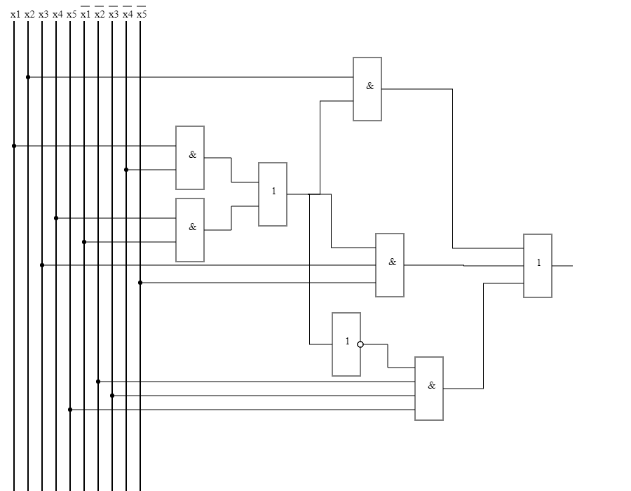

**С однофазными входами**

SQ  = 25, τ=6t

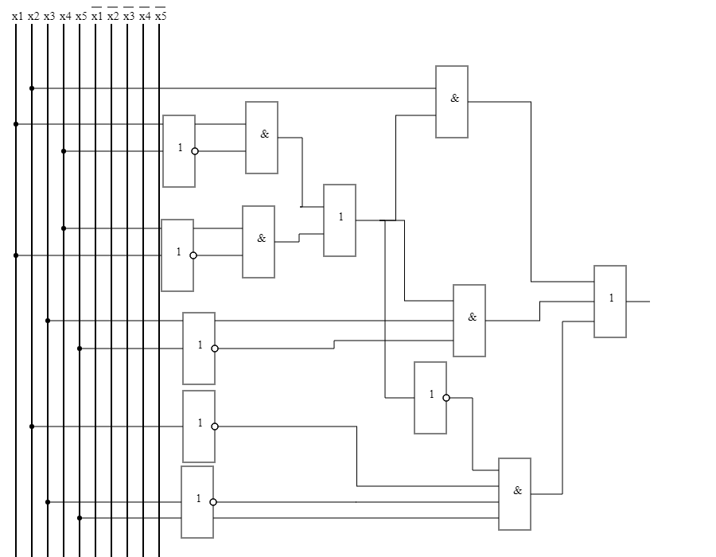

**2.7. Синтез комбинационных схем в универсальных базисах**

**Базис (И-НЕ)**

φ= x1¬x4 ∨ ¬x1x4 = ¬¬(x1¬x4 ∨ ¬x1x4) = ¬(¬(x1∧¬x4) ∧ ¬ (¬x1∧x4)) =

= (x1 |¬x4) | (¬x1 | x4)

f =(x2φ) ∨ (x3¬x5φ) ∨ (¬x2¬x3x5(x1x4 ∨ ¬x1¬x4))=

=(x2|φ) | (x3|¬x5|φ) | (¬x2|¬x3|x5|((x1|x4)| (¬x1|¬x4)))

SQ F= 18, SQ φ = 7

SQ  = 25, τ=4t

Проверка на наборах:

00000 – 0

00001 – 1

